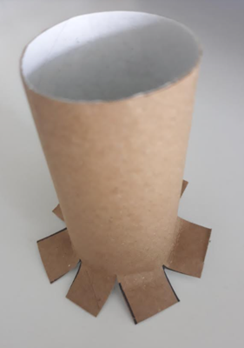

Fold the sections out to create a stable base to glue the tube down.

Each cut needs to be the same size, height and width.

Make small cuts from the bottom heading up to the middle.

**Flange**

A way to connect tubes or pipes